Score for this quiz: 3 out of 10 *
Submitted Aug 21 at 12:47pm
This attempt took 23 minutes.

Question 1
Not yet graded / 1 pts
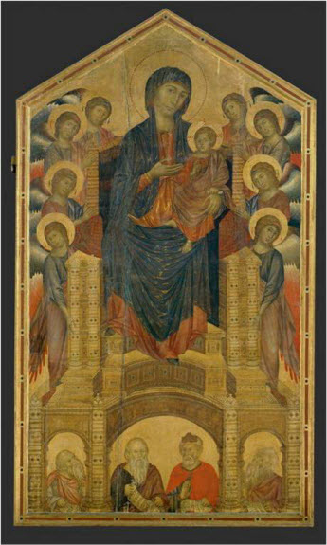
Name the artist, the title, and the date for this work.
Your Answer:
Cimabae
Modonna with a child
1280

Question 2
1 / 1 pts
When Cimabue meets Giotto, the boy was making a drawing in the sand. Which animal was he drawing?

Sheep

Yes!

Goat

Cow

Pig

Horse

Question 3
Not yet graded / 1 pts
In his Arena Chapel frescoes, Giotto replaces the golden background of the Byzantine tradition with what?
Your Answer:
He replaces it with a virgin

Question 4
Not yet graded / 1 pts
What is shown in a “Deposition” scene?
Your Answer:
scene of Jesus Christ lamentation

Question 5
Not yet graded / 1 pts
Which artist shows us – for the first time in Western Art – people’s back sides?
Your Answer:
Giotto

Question 6
Not yet graded / 1 pts
What is the meaning of the word ICON?
(Hint: I'm not looking for the definition of the word icon.)
Your Answer:
It is an image or a depiction that comes from Byzantine

Question 7
1 / 1 pts
In the Byzantine tradition artists learn by copying their teacher’s work. True or false?
True

You are correct.
False

Question 8
Not yet graded / 1 pts
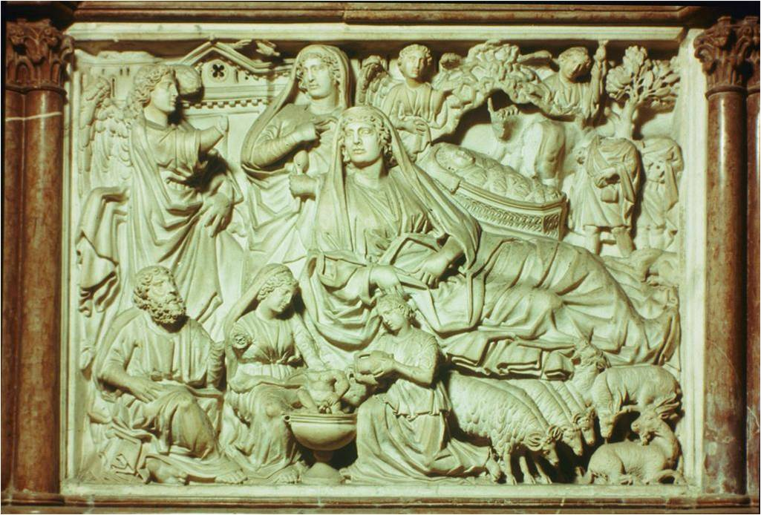
Name the ARTIST, the TITLE of the work and the DATE.
Your Answer:
Artist is Niccola Pisano
Title is Pulpit Pisa (Italy)
Date is 1260

Question 9
1 / 1 pts
Cimabue was a very famous artist in?
Ravenna

Milan

Tuscany

Yes!
Venice

Rome

Question 10
Not yet graded / 1 pts
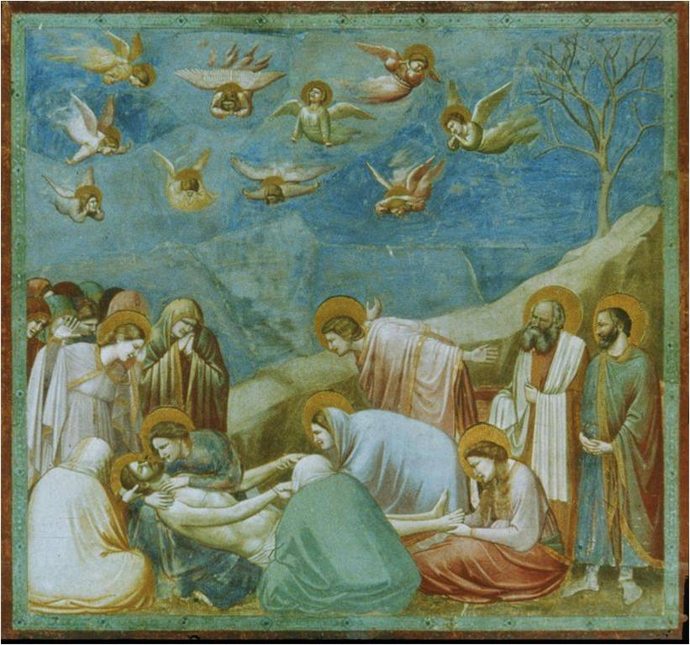
Name the ARTIST, the TITLE of the work and the DATE.
Your Answer:
Artist is Giotto
Title is Arena chapel Disposition. Padua (Italy).1305
Quiz Score: 3 out of 10
PreviousNext
Submission Details:

